**Batch: D1 Roll No.: 16010122096**

**Experiment / assignment / tutorial No. 05**

**Grade: AA / AB / BB / BC / CC / CD /DD**

**Signature of the Staff In-charge with date**

**Experiment No.:5**

|  |
| --- |
| **TITLE:** Flow control Mechanism: Selective Repeat ARQ Sliding Window Protocol using Socket programming |

**__________________________________________________________________________**

**AIM:** Implementation of Flow Control Mechanism: Stop and Wait ARQ / Go-Back- N

/ Selective Repeat Sliding Window Protocol ARQ using sockets.

**Expected Outcome of Experiment:**

**CO:**

**__________________________________________________________________________**

**Books/ Journals/ Websites referred:**

1. A. S. Tanenbaum, “Computer Networks”, Pearson Education, Fourth Edition
2. B. A. Forouzan, “Data Communications and Networking”, TMH, Fourth Edition

__________________________________________________________________________

**Pre-Lab/ Prior Concepts:**

Java Socket Programming, Flow Control, Go-Back-Stop and Wait

**__________________________________________________________________________**

**New Concepts to be learned:** Window Flow Control **__________________________________________________________________________**

**Design of Go-Back-N ARQ**

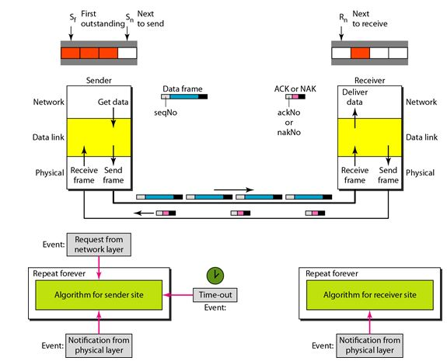

1. Take data from user about how many bit windows is case of go back n and selective repeat.
2. Generate frames randomly and show the transmission
3. Generate the random number for the frame to be lost.
4. For Go – Back – N transmit all the frames after that number till max number
5. For Selective repeat transmit the selected frame which is not received by the receiver.

**IMPLEMENTATION: (**printout of code)

Client.py

import socket

import time

import random

WINDOW_SIZE = 4

PACKET_DROP_PROBABILITY = 0.3

def client():

sender_socket = socket.socket(socket.AF_INET, socket.SOCK_DGRAM)

sender_socket.settimeout(2)

addr = ('localhost', 12345)

base = 0

next_seq = 0

data = [str(i) for i in range(10)]

while base < len(data):

while next_seq < base + WINDOW_SIZE and next_seq < len(data):

if random.random() > PACKET_DROP_PROBABILITY:

sender_socket.sendto(data[next_seq].encode(), addr)

print(f"Sent packet {next_seq}")

else:

print(f"Dropped packet {next_seq}")

next_seq += 1

try:

ack, _ = sender_socket.recvfrom(1024)

ack = int(ack.decode())

print(f"Received ACK {ack}")

base = ack + 1

if base == next_seq:

time.sleep(1)

except socket.timeout:

print("Timeout, resending window")

next_seq = base

if __name__ == "__main__":

client()

server.py

import socket

import random

ACK_DROP_PROBABILITY = 0.3 # 30% chance of dropping ACKs

def server():

receiver_socket = socket.socket(socket.AF_INET, socket.SOCK_DGRAM)

receiver_socket.bind(('localhost', 12345))

expected_seq = 0

while True:

data, addr = receiver_socket.recvfrom(1024)

seq = int(data.decode())

if seq == expected_seq:

print(f"Received packet {seq}")

if random.random() > ACK_DROP_PROBABILITY:

receiver_socket.sendto(str(seq).encode(), addr)

print(f"Sent ACK {seq}")

else:

print(f"Dropped ACK {seq}")

expected_seq += 1

else:

if random.random() > ACK_DROP_PROBABILITY:

receiver_socket.sendto(str(expected_seq - 1).encode(), addr)

print(f"Sent duplicate ACK {expected_seq - 1}")

else:

print(f"Dropped duplicate ACK {expected_seq - 1}")

if __name__ == "__main__":

server()

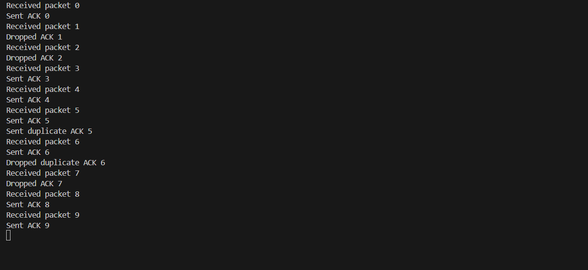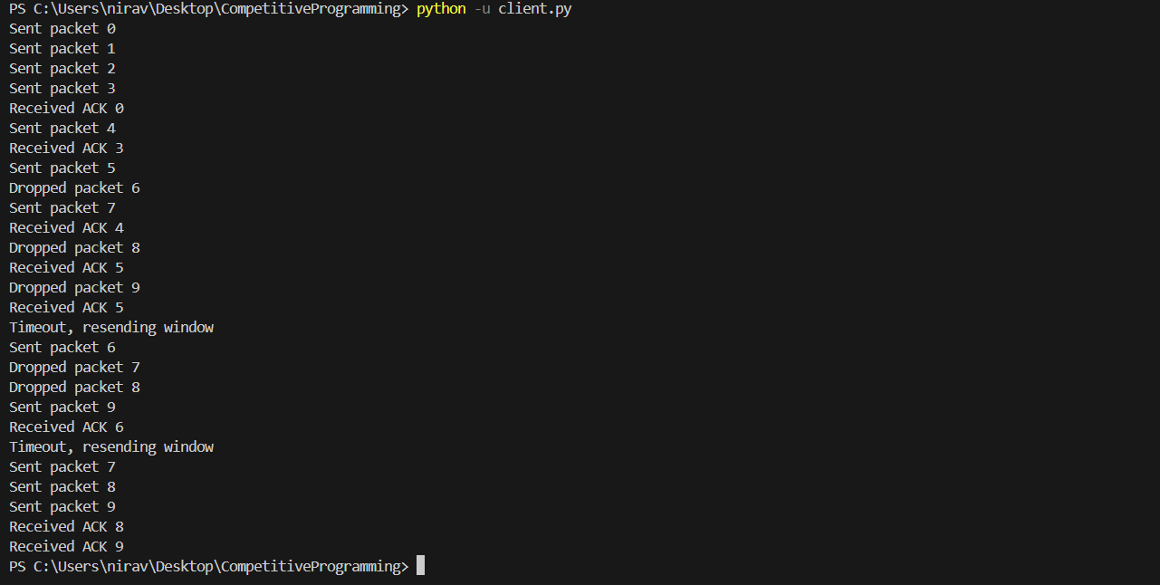

**CONCLUSION:**

Selective Repeat ARQ enhances reliable data flow in networks by selectively retransmitting lost frames, demonstrating improved efficiency in flow control.

**Post Lab Questions**

1. Compare Go-Back-N and Stop and Wait.

* **Stop and Wait** sends one frame at a time and waits for an acknowledgment before sending the next frame, making it simpler but less efficient over large distances or high-speed networks.
* **Go-Back-N** allows multiple frames to be sent within a "window size" before waiting for an acknowledgment, retransmitting from the point of error if a frame is lost, thus improving throughput compared to Stop and Wait.

1. What is Flow Control and why it is necessary?

Flow control is a technique used to manage the rate of data transmission between sender and receiver, ensuring the receiver's buffer isn’t overwhelmed. It is necessary to prevent data loss and ensure efficient communication, especially when devices have different processing speeds or buffer capacities.

1. The maximum window size for data transmission using the selective reject protocol with n-bit frame sequence numbers is  
   a) 2n            b) 2n-1                    c) 2n-1                   d)2n-2

**Date: __________ Signature of Faculty In-charge**